LIQUID WASTE GENERATOR

POLLUTION PREVENTION PLAN

Prepared For:

Company Name

Items that must be included or addressed in the plan

LIQUID WASTE GENERATOR
POLLUTION PREVENTION PLAN

1. GENERAL INFORMATION:

Name of Company:
Facility Address:

Mailing Address:

Primary Contact: Name:
Title:
Phone#: Work:
Emergency:
Email:

Alternate Contact: Name:
Title:
Phone#: Work:
Emergency:
Email:

Description of Service and Operations:

Engine Overhaul Transmission Oil Change/Tune Up Car Wash Auto Body Other________________________________________________

2. SCOPE OF PLAN:

This Pollution Prevention Plan (Plan) is written to ensure compliance with the Liquid Waste Control Program Rules and the Revised Ordinances of Sioux Falls, SD. The Plan applies to all hazardous or non-hazardous wastes discharged or that have a potential to be discharged into the Sioux Falls Publicly Owned Treatment Works (POTW). The Plan calls for a proactive commitment to its objectives by company management, and for involvement from every person employed at the facility.

3. PLAN OBJECTIVES:

- Eliminate any discharge of unacceptable waste to our facility’s liquid waste interceptor or receptacle that may affect the POTW as listed in Section 5

- Maintain company waste awareness through employee training

4. MEANS TO ACCOMPLISH OBJECTIVES :

Chemical Storage:

All chemicals shall be:
- Stored in approved containers
- Stored away from interceptors and other liquid waste recepticals
- Stored with proper secondary containment.

Pollution Prevention Equipment and Supplies:

Floor Dry Spill Socks Pads Other ____________________________

Pollution Prevention Procedures:

Minor Spill:
- Floor dry or other absorbent will be used to soak-up any spilled material.
- The absorbant material will be properly handled and disposed.

Major Spill:
- Absorbent socks will be used to surround and contain the spill.
- Spill should not be allowed to enter the sanitary sewer
- Notify proper authority and/or emergency personal
- The responsible party will assess proper disposal and/or reuse of material

Waste Handling Procedures: If applicaple, identify the storage and disposal of the following materials at your facility.

Used Solvent: Onsite N/A Quantity:_____________________________
Storage and Containment__________________________________________________
Disposal Method_________________________________________________________

Used Oil: Onsite N/A Quantity:_____________________________
Storage and Containment__________________________________________________
Disposal Method_________________________________________________________

Used Antifreeze: Onsite N/A Quantity:_____________________________
Storage and Containment__________________________________________________
Disposal Method_________________________________________________________

Liquid Waste Interceptor Maintenance:

Liquid Waste Covered under Plan:
Trench Drain(s)/Interceptor(s) Number on site:________
Holding Tank(s) Number on site:________
Water Operated Machinery Number on site:________

Cleaning Schedule:
The above named liquid waste structures will be cleaned thoroughly by a Licensed
Liquid Waste Hauler on an as needed basis but no less than _________________.

5. UNACCEPTABLE WASTE:

- Used Oil and Lubricants | - Aqueous Parts Washer Sludge
- Used Antifreeze | - Categorical Wastes
- Solvents | - Hazardous Waste

6. POLICY STATEMENT:

Our company generates liquid waste that is collected and hauled to the City of Sioux Falls
Publicly Owned Treatment Works. Every attempt will be made to prevent hazardous or incompatible wastes from entering the sanitary sewer system. Our liquid waste structures will be serviced in accordance to our cleaning schedule. Our company will provide adequate equipment and training so that all employees understand proper spill containment and cleanup.

7. CERTIFICATION:

Responsible Party: By signing below you agree to the policy statement listed above.

Name: ______________________________ Title: _________________________

__________________________________ _______________________
(Signature) (Date)

Official City Use Only – Plan Review

General Information Supplies Waste Handling Maintenance Certification Sketch

Notes:_____________________________________________________________________________

Review Date:______________________Reviewer:___________________________________________
8. Facility Sketch:

Please attach or draw below a sketch of your facility. Your sketch should include the location of any floor drains, trench drains, sand/oil interceptors, holding tanks, parts washers, bulk new and used fluid storage, and spill containment supplies
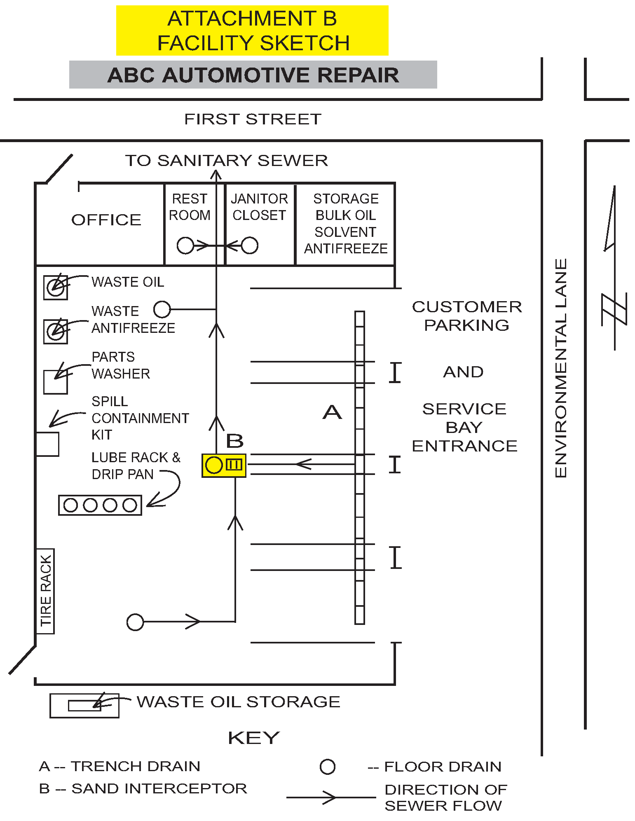
Used Oil
Antifreeze
Used
Parts Washer
Spill
Containment
Supplies
Floor
Drain
Used Oil Storage
Direction of
Sewer Flow
Sand/Oil
Interceptor
Street
Trench
Drain
Bulk New
Fluid Storage
Facility Sketch Example
To Sanitary Sewer or Holding Tank
Janitor
Closet
Office
Rest
Room
Customer
Parking

And

Service
Bay
Enterance

